**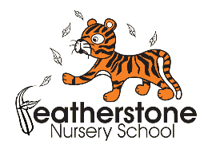***Federation of Osborne and Featherstone Nursery Schools*

**FOOD AND NUTRITION POLICY**

**September 2025**

**Policy Statement**

The governing board and staff of the Federation of Osborne and Featherstone Nursery Schools are dedicated to supporting the health, development, and well-being of every child through the provision of healthy, balanced and nutritious meals and snacks. Our food and nutrition practices are guided by the statutory EYFS framework, the 2025 EYFS Nutrition Guidance and School Food Standards.

**Rights Respecting School**

This policy is in accordance with the 1989 United Nations Convention on the Rights of the Child (UNCRC)

* Article 3 - The best interests of the child must be a top priority in all things that affect children.

**Our Aims**

* To provide meals, snacks and drinks that are healthy, balanced and nutritious to ensure that children:
  + Get the right amount of nutrients and energy they need while they are growing rapidly.
  + Develop positive eating habits early on. Children’s early experiences with food can shape future eating habits. This can impact children’s long term health including, maintaining a healthy weight, and good oral health.
* To foster healthy eating habits and a positive relationship with food.
* To work collaboratively with families to provide a healthy and balanced diet for children that takes into account their cultural and dietary needs in order to create a safe and inclusive environment for all children to eat.
* To reduce health inequalities and set the foundations for a lifetime of good health.

**Food and Drink Provision**

We provide a healthy breakfast, mid-morning snack, lunch, and afternoon snack.

Meals include a variety of fruits and vegetables, starchy carbohydrates, protein sources, and dairy or plain, fortified plant-based alternatives. Please see Appendix 1 for food and drink guidelines.

We provide at least 3 different types of starchy food and a variety of wholegrain and white starchy foods across breakfasts, snacks and lunch each week.

Snacks include plain starchy food such as plain savoury crackers, or unsalted unsweetened rice or corn cakes as part of the snack each day.

A portion size for a child aged 1 to 5 is generally smaller than an adult portion. Portions are appropriate for the child’s body size and appetite. For two year olds, portion size is usually roughly the size of their clenched fist. About half a piece of fruit or a tablespoon of vegetables is a good portion for a snack. Please refer to Appendix 4 to see a guide on portion sizes.

Children are offered water with meals and milk and water is available at all times. We avoid sugary drinks (including fruit juices, squash and smoothies) and skimmed and 1% cows’ milk.

Some foods use red, amber and green colour coding to tell you if a food has high, medium or low amounts of fat, saturated fat, sugars and salt. Red means high, amber means medium, green means low. We will aim to provide food that has mostly green on the label as this is a healthier choice. Amber means neither high nor low, so we will also provide foods with all or mostly amber on the label too.

We avoid:

* foods high in saturated fat, salt and/or sugar like cakes, sweet and savoury pastries, biscuits, crisps, chocolate and other confectionary.
* artificial sweeteners as they may encourage children to prefer very sweet foods.
* sweetened yoghurts and fromage frais (including non-dairy alternatives) and choose plain unsweetened options.
* cereals labelled as ‘high’ (red) in sugar such as sugar-coated or chocolate-flavoured cereals.
* flavoured dried rice, pasta and noodle products e.g. packets and pots of instant flavoured noodles, pasta and rice.
* dried fruit as a snack.
* fruit tinned in syrup and choose fruit tinned in juice
* added salt and sugar in tinned vegetables and pulses and choose no added salt and sugar options or those tinned in water.
* sugary drinks (including fruit juices, squash and smoothies) and skimmed and 1% cow’s milk.

Parents must refer to our Healthy Packed Lunches policy if they are providing their own lunch for their child.

**Menu Planning**

Menus are planned on a 3-week rotation and reviewed termly. Children over 12 months old need to eat regularly, with breakfast, lunch (consisting of 2 dishes), and tea (consisting of 2 dishes), plus 2 or 3 snacks every day. The additional dish could be a starter such as a soup, side dish such as vegetable sticks and dip or second dish such as plain yoghurt and fruit. Please see Appendix 1 for further information.

We ensure cultural and dietary diversity is reflected in our meals.

Menus are displayed in the nursery and shared with parents.

We involve children in food-related activities to encourage interest and familiarity.

**Special Dietary Requirements**

We cater for children with allergies, intolerances, coeliac disease, medical or cultural dietary needs, vegetarianism, veganism or eating a plant-based diet, additional support needs and other special diets. Parents must inform the nursery of any dietary requirements upon registration.

Some children may have specific dietary needs because of physical or developmental

issues, which may affect their ability to eat independently, for example difficulty with

swallowing. These children may need to have their food prepared in a particular way to make it easier to eat and they may need one to one support at meal and snack times. Individual care plans are created in collaboration with parents and health professionals. If a child requires a special diet for a medical reason not discussed above, we will require written confirmation from their qualified health professional about the nature of their specific needs so that their nutritional requirements can be achieved. This information will be recorded, updated regularly and communicated to all staff involved in the preparing and handling of food.

**Food from Home**

We have a regulatory obligation to provide healthy, balanced and nutritious food to children and encourage healthier food choices for packed lunches.

Food provided from home must align with the healthy options offered at the Federation of Osborne and Featherstone Nursery Schools, so that children receive consistent messages about nutrition.

Parents providing packed lunches must follow our Healthy Packed Lunch Policy. We do not allow:

* foods high in saturated fat, salt and/or sugar like cakes, sweet and savoury pastries, biscuits, crisps, chocolate and other confectionary
* sweetened yoghurts and fromage frais
* flavoured rice, pasta and noodle products e.g. packets and pots of instant flavoured noodles, pasta and rice
* dried fruit as a snack
* sugary drinks (including fruit juices, squash and smoothies)
* skimmed milk or 1% cow’s milk
* food containing artificial sweeteners

**Food Safety and Hygiene**

All food brought from home will be checked for potential allergens so that the risk of cross contamination is reduced.

All food is prepared in accordance with Food Standards Agency regulations. All food served to children will be prepared in a way to prevent choking. See appendix 2.

Staff involved in food handling are trained in Food Hygiene and Safety.

We maintain high standards of cleanliness in all food preparation and eating areas.

**Celebrations and Rewards**

We celebrate birthdays and cultural events with non-food-based activities or healthy treats. Examples of non-food-based activities: bubbles and stickers. Examples of healthy treats: fruit platters. We do not allow cake or sweets to be brought into nursery. If you would like to celebrate your child’s birthday by bringing something in to share, please make sure it is either non-food-based or a healthy treat.

Food is never used as a reward or punishment.

**Mealtimes as Learning Opportunities**

* Mealtimes are calm, social occasions where children are encouraged to try new foods.
* Staff sit with children to model good eating habits and support self-feeding skills.
* Children are encouraged to talk about food, textures, and tastes.

**Learning about Food**

We are passionate about engaging children in planting activities to support their food choices, nutrition and overall health. Research shows that children who grow their own food, are more likely to eat it and they are more open to trying new fruit and vegetables.

Growing fruits, vegetables and herbs in pots or bags provides a sustainable source of ingredients for meals or snacks.

**Cooking with Children**

Cooking is a great experience for young children and helps to create a positive relationship with food. There are lots of benefits of providing fun food activities for children:

* Confidence – children are more likely to try new foods and widen their diet
* Language – children learn new vocabulary and words from different languages
* Physical – cooking helps children practice physical skills, such as gross and fine motor skills, which help muscle development and hand-eye coordination
* Emotional – children can feel competent and proud of themselves when cooking
* Relationships – cooking activities can support team work and relationships between children and adults
* Mathematics – children will learn numbers through counting and measuring
* Science – children can observe how different ingredients mix together and the effects of heat and cooling
* Understanding the world around them – including where spices come from, how vegetables are grown and sustainability
* Diversity and culture – children can learn where food comes from and how different cultures use different cooking techniques.

**Partnership with Parents**

We regularly share information about children’s eating habits and preferences.

We provide resources and workshops to support healthy eating at home.

Feedback from parents is welcomed and used to improve our food provision.

**Monitoring and Review**

The policy is regularly monitored by the Head Teacher and Governing Board to ensure that it is working as effectively as possible.

This policy will be reviewed on a three yearly basis and whenever significant changes to the systems and arrangements take place.

Policy Agreed by Governors on:

Signed: …………………………………………………… Review Date: September 2028

Appendix 1

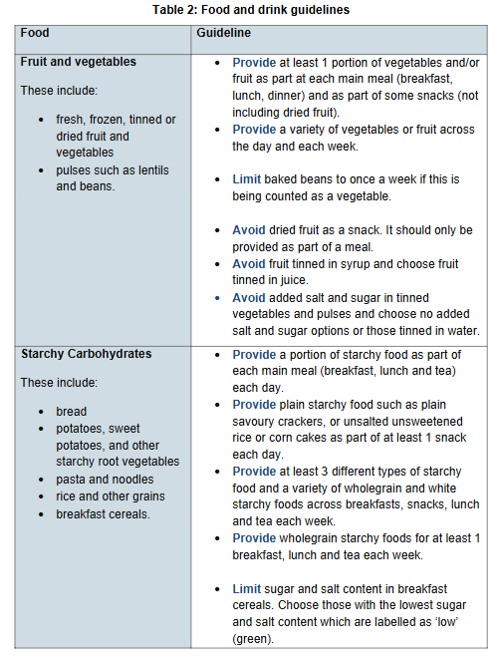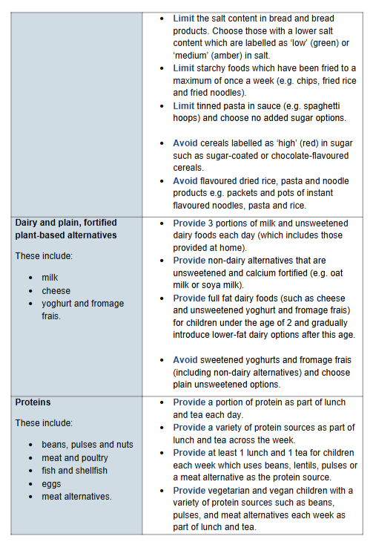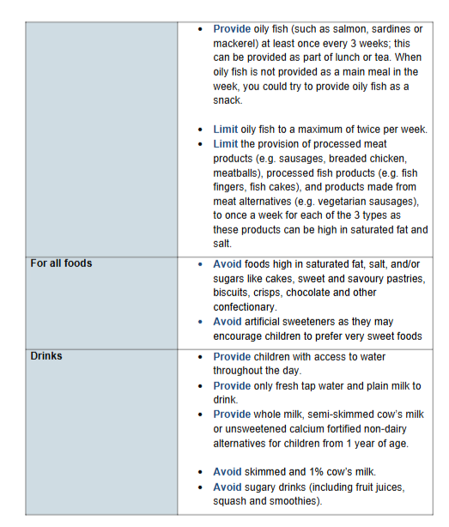

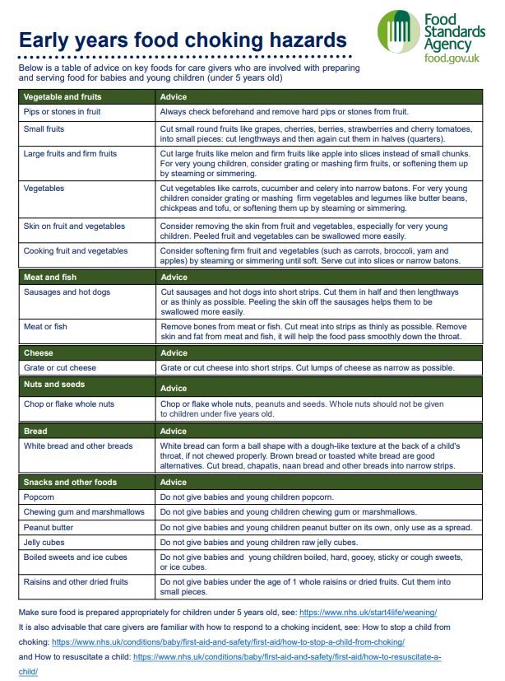Appendix 2

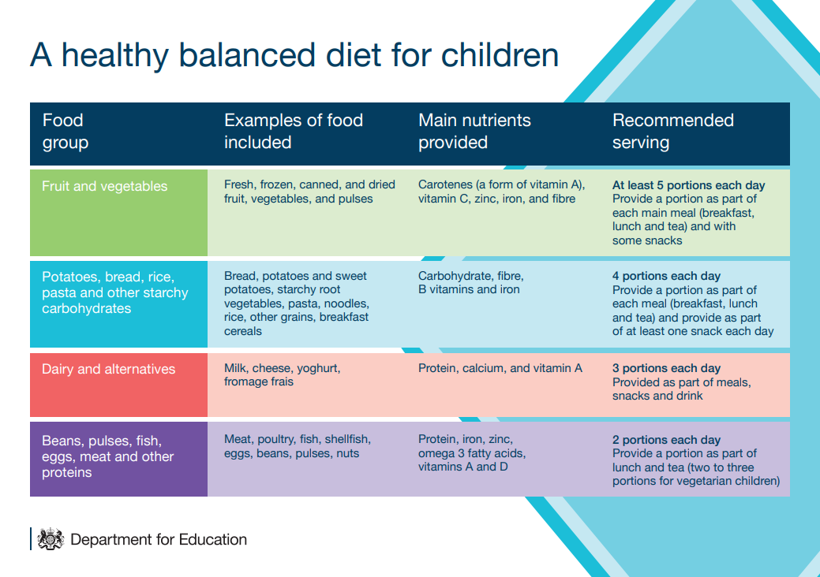Appendix 3

Appendix 4

